Coimbatore, also better-known as Kovai, is a main city within the Indian state of TamilNadu. Located on the banks of the Noyyal watercourse encircled by the Western Ghats, it is the second largest city within the state when urban center and also the sixteenth largest urban agglomeration in Asian nation. It is one amongst the highest rising tier-II cities in Asian nation and a serious hub for textiles, industries, commerce, education, information technology, healthcare and producing in Tamil Nadu. "Manchester of South India" attributable to its cotton production and textile industries. Coimbatore is also remarked because the "Pump City" and it provides nearly half India's necessities of motors and pumps. The city is one amongst the biggest exporters of jewelry, wet grinders, poultry and auto elements with "Coimbatore Wet Grinder".
Coimbatore was part of Kongu Nadu throughout the Sangam amount between 1st and the fourth centuries metal and was dominated by the Cheras because it served because the jap entrance to the Palakkad Gap, the principal trade route between the west coast and Madras. Coimbatore was located on the ancient Roman trade route that extended from Muziris to Arikamedu in South Asian nation. The medieval Cholas conquered the Kongu Nadu in the 10th century metal. The region was ruled by Vijayanagara Empire in the fifteenth century followed by the Nayaks United Nations agency introduced the Palayakkarar system beneath that Kongu nadu region was divided into twenty four Palayams. In the later a part of the 18th century, the Coimbatore region came under the Kingdom of Mysore and following the defeat of tree grand Turk within the Anglo-Mysore Wars, the British East India Company annexed Coimbatore to the Madras Presidency in 1799. The Coimbatore region played a distinguished role in the Second Poligar War (1801) once it absolutely was the realm of operations of Dheeran Chinnamalai.

Early history
Coimbatore has been occupied since the early Sangam amount. The area was called Kongunadu and was conquered by semi-independent group leader United Nations agency allocated nominal loyalty to the Chera kingdom. big amount of Roman coins and option artifacts discovered in the region attest to the presence of Roman traders.

Medieval period of coimbatore
The Medieval cholas conquered the region in the 10th century metallic element. They constructed a road known as "Rajakesari Peruvazhi". During the ninth century metallic element, Coimbatore was ruled by Irula chief Kovan or Covan throughout whose reign the town of Coimbatore was created, supposedly at the request of a Chera king United Nations agency attended Cuntarar on a pilgrim's journey to the Patteswarar Temple, Perur Following the decline of the Cholas, Coimbatore was ruled for crisp periods by the Pandyas, Madurai Sultanate, Hoysalas, Vijayanagar Empire and the Madurai Nayaks and Thanjavur Nayaks. The Nayaks established the Palayakarar system in the region. The whole country was divided into 24 Palayams.

About Coimbatore
Coimbatore, also better-known as Kovai, is a main city within the Indian state of TamilNadu. Located on the banks of the Noyyal watercourse encircled by the Western Ghats, it is the second largest city within the state when urban center and also the sixteenth largest urban agglomeration in Asian nation. It is one amongst the highest rising tier-II cities in Asian nation and a serious hub for textiles, industries, commerce, education, information technology, healthcare and producing in Tamil Nadu. "Manchester of South India" attributable to its cotton production and textile industries. Coimbatore is also remarked because the "Pump City" and it provides nearly half India's necessities of motors and pumps. The city is one amongst the biggest exporters of jewelry, wet grinders, poultry and auto elements with "Coimbatore Wet Grinder".
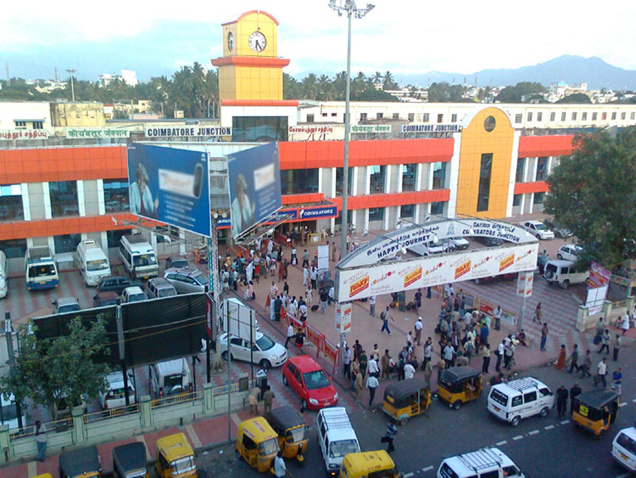
Coimbatore was part of Kongu Nadu throughout the Sangam amount between 1st and the fourth centuries metal and was dominated by the Cheras because it served because the jap entrance to the Palakkad Gap, the principal trade route between the west coast and Madras. Coimbatore was located on the ancient Roman trade route that extended from Muziris to Arikamedu in South Asian nation. The medieval Cholas conquered the Kongu Nadu in the 10th century metal. The region was ruled by Vijayanagara Empire in the fifteenth century followed by the Nayaks United Nations agency introduced the Palayakkarar system beneath that Kongu nadu region was divided into twenty four Palayams. In the later a part of the 18th century, the Coimbatore region came under the Kingdom of Mysore and following the defeat of tree grand Turk within the Anglo-Mysore Wars, the British East India Company annexed Coimbatore to the Madras Presidency in 1799. The Coimbatore region played a distinguished role in the Second Poligar War (1801) once it absolutely was the realm of operations of Dheeran Chinnamalai.

History of Coimbatore

Early history
Coimbatore has been occupied since the early Sangam amount. The area was called Kongunadu and was conquered by semi-independent group leader United Nations agency allocated nominal loyalty to the Chera kingdom. big amount of Roman coins and option artifacts discovered in the region attest to the presence of Roman traders.

Medieval period of coimbatore
The Medieval cholas conquered the region in the 10th century metallic element. They constructed a road known as "Rajakesari Peruvazhi". During the ninth century metallic element, Coimbatore was ruled by Irula chief Kovan or Covan throughout whose reign the town of Coimbatore was created, supposedly at the request of a Chera king United Nations agency attended Cuntarar on a pilgrim's journey to the Patteswarar Temple, Perur Following the decline of the Cholas, Coimbatore was ruled for crisp periods by the Pandyas, Madurai Sultanate, Hoysalas, Vijayanagar Empire and the Madurai Nayaks and Thanjavur Nayaks. The Nayaks established the Palayakarar system in the region. The whole country was divided into 24 Palayams.

Anglo-Mysore Wars
Coimbatore was desirable by the Mysore sultans as well as British troops for the amount of the Anglo-Mysore Wars. The city was taken by the forces of Brits East Indies Company in 1768 however was forced to discard it thanks to treason. Colonel Fullarton occupied the town in 1783 however later came to pride of Bolivia grand Turk as per the accord of Mangalore. At the beginning of the Third Mysore War, Coimbatore was, once again, taken by the British. Tipu grand Turk enclosed the town doubly and revolted within the initial, he was successful in the second and Coimbatore relinquished in Gregorian calendar month 1791. The commanders of the garrison, Lieutenant Chalmers and Lieutenant Nash were taken as prisoners to Seringapatnam. Coimbatore fell to the British at the tip of the Third Mysore War but was fixed to pride of Bolivia grand Turk at the halt of hostilities. Coimbatore was eventually annexed by the British on the defeat and death of Tipu grand Turk in 1799. Coimbatore was taken by the Polygars in 1800 and was an necessary defensive structure within the Polygar Wars. It was made capital of Coimbatore district in 1865.

